Test 9

# Set 1

1. Write a recursive method to check if a given string is a palindrome (reads
2. The same forward and backward).
3. Test Cases:
4. ● “racecar” → true
5. ● “hello” → false

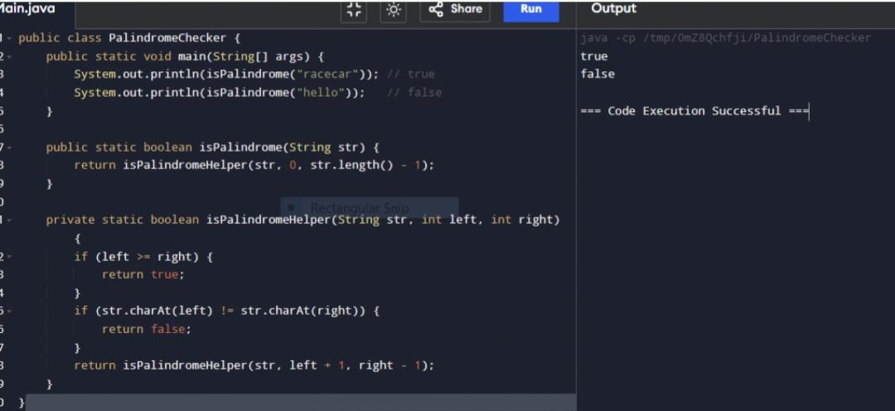Ans:

2..**Write a method to validate an email address using regular expressions.**

**Test Cases:**

**●** [**test@example.com**](mailto:test@example.com) **→ true**

**● “invalid-email” → false**

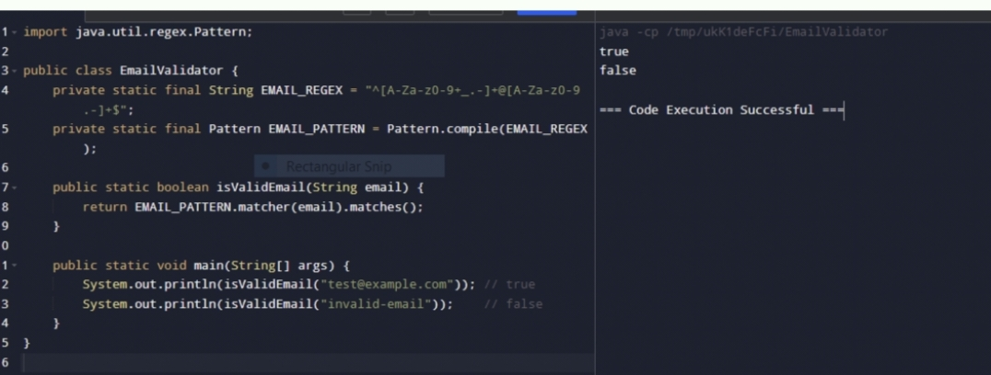**Ans:**

**3.Write a recursive method to calculate the factorial of a given number.**

**Test Cases:**

**● 5 → 120**

**● 3 → 6**

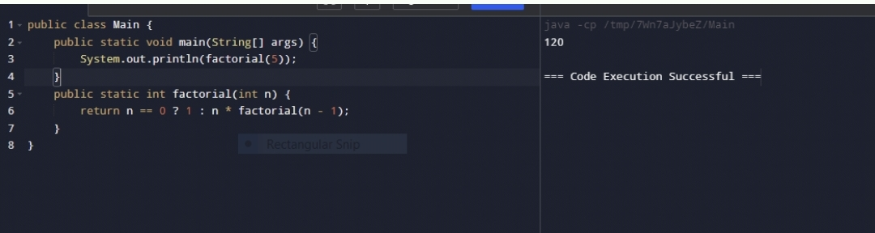**Ans:**

**4.Write a method to compress a string using the counts of repeated**

**Characters. For example, “aabcccccaaa” should become “a2b1c5a3”.**

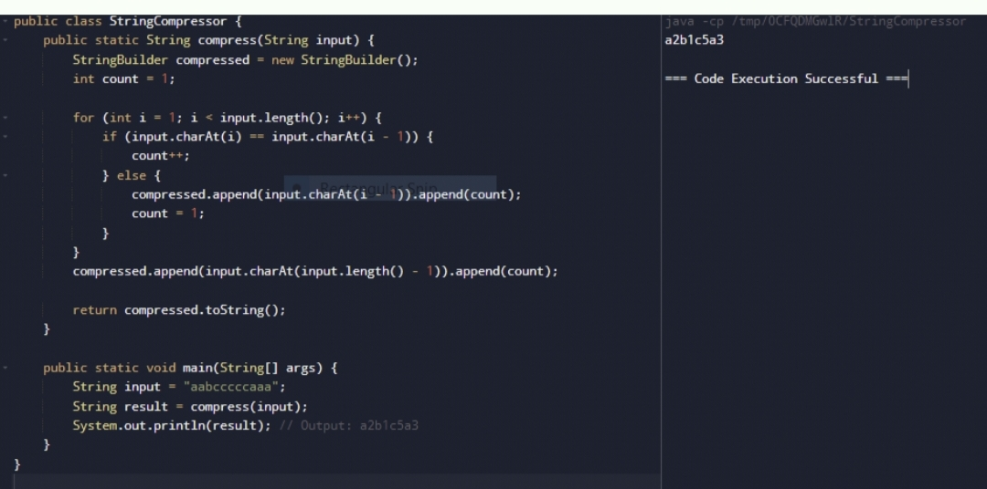

**5.Write a method to check if a given string matches a specified pattern using**

**Regular expressions. For example, check if the string is a valid phone**

**Number.**

**Test Cases:**

**● “123-456-7890” → true**

**● “1234567890” → false**

**Ans :**

